1. Assign two double number as input and convert them to integer then add these numbers and print the result

Input: 2.5 3.75

Output: 2 + 3 = 5

Ans.1.

using System;

namespace LabTask1_AddTwoNumbers

{

class AddTwoNumbers

{

static void Main(string[] args)

{

double num1 = Double.Parse(Console.ReadLine());

double num2 = Double.Parse(Console.ReadLine());

int n1 = Convert.ToInt32(num1);

int n2 = Convert.ToInt32(num2);

int addresult = n1 + n2;

Console.WriteLine("{0} + {1} = {2}", n1, n2, addresult);

Console.ReadLine();

}

}

}

2. Create a Console Application of Calculator which will calculate addition(+), subtraction(-), Multiplication(*) , Division (/), Power(^).

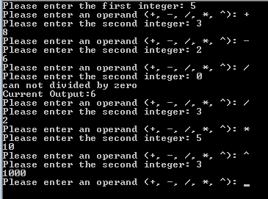

Ans.2.

using System;

namespace LabTask1_Calculator

{

class Calculator

{

static void Main(string[] args)

{

Console.WriteLine("Calculator using C#");

Console.WriteLine("Enter num1 == -1 && operand == 'e' && num2 == -1 OR operand == 'e' && num2 == -1 to exit");

Console.Write("Please enter the first integer: ");

int num1 = Convert.ToInt32(Console.ReadLine());

while (true)

{

Console.Write("Please enter the operand (+, -, /, *, ^): ");

char operand = Convert.ToChar(Console.ReadLine());

Console.Write("Please enter the second integer: ");

int num2 = Convert.ToInt32(Console.ReadLine());

if (operand == '+')

{

int add_result = num1 + num2;

Console.WriteLine("{0}", add_result);

num1 = add_result;

}

else if (operand == '-')

{

int sub_result = num1 - num2;

Console.WriteLine("{0}", sub_result);

num1 = sub_result;

}

else if (operand == '/')

{

try

{

int div_result = num1 / num2;

Console.WriteLine("{0}", div_result);

num1 = div_result;

}

catch (DivideByZeroException)

{

Console.WriteLine("can not divided by zero");

Console.WriteLine("Current Output:{0}", num1);

}

}

else if (operand == '*')

{

int mul_result = num1 * num2;

Console.WriteLine("{0}", mul_result);

num1 = mul_result;

}

else if (operand == '^')

{

double pow_res = Math.Pow(num1, num2);

Console.WriteLine("{0}", pow_res);

num1 = (int)pow_res;

}

else if (num1 == -1 && operand == 'e' && num2 == -1 || operand == 'e' && num2 == -1)

{

Console.WriteLine("\nThank you for using C# Calculator.");

break;

}

else

{

Console.WriteLine("Wrong Input.Try Again!");

}

}

}

}

}